

**SATS – Custom Email Alerts for Smart Detection in Azure Application Insights**

Please direct all Enquiries with Respect to this Document to:

Coforge SS-Cloud_APAC

|  |  |  |  |
| --- | --- | --- | --- |
| **Level** | **Name** | **Contact No** | **Email** |
| **L1** | SS-Cloud_APAC Team | 9711880047 | [SS-Cloud_APAC@coforge.com](mailto:SS-Cloud_APAC@coforge.com) |
| **L2** | Saroj Kumar Gupta (Infra) | 7407894320 | sarojkumar.gupta@coforge.com |
| Prabal Mishra (OS Team) | 8826108233 | [Prabal.mishra@coforge.com](mailto:Prabal.mishra@Coforgetech.com) |
| **L3** | Bhupendra Sharma | 9871144731 | bhupendra.1.sharma@coforge.com |
| **L4** | Mayank Kumar Mishra | 9999673041 | mayank.mishra@coforge.com |
| **L5** | Puneet Chopra | 9560644554 | puneet.chopra@coforge.com |

SATS

|  |  |  |  |
| --- | --- | --- | --- |
| Level | Name | Email ID | Contact Number |
| **Level 1** | Ajaya Kumar Sabata | [Ajaya.Sabata@coforge.com](mailto:Ajaya.Sabata@coforge.com) | 7483978967 |
| **Level 2** | Madan Kumar | [Madan.kumar@coforge.com](mailto:Madan.kumar@coforge.com%20) | 9845292755 |
| **Level 3** | Pankaj Jain | [Pankaj.Jain@coforge.com](mailto:Pankaj.Jain@coforge.com) | +65 9299 6669 |
| **Level 4** | Abhishek Avinash Sehgal | [Abhishek.Sehgal@coforge.COM](mailto:Abhishek.Sehgal@coforge.COM) | 6591187384 |

Document Control

|  |  |  |  |  |  |
| --- | --- | --- | --- | --- | --- |
| **Version** | **Date** | **Author** | **Reviewer** | **Revision Requests** | **Approving Authority** |
| 1.0 | 16-10-2025 | Ashutosh Padhi |  | Initial Version |  |

Table of Contents

1. Purpose 4

2. Scope 4

3. Audience 4

4. Prerequisites 4

5. Follow below steps for adding custom email recipients to Smart Detection alerts 4

# Purpose

To outline the process for adding custom email recipients to Smart Detection alerts in Azure Application Insights, ensuring the right teams receive anomaly notifications.

# Scope

Applies to:

* All Azure Application Insights resources.
* Non-preview Smart Detection rules.

# Audience

The intended audience of this document are COFORGE SS-Cloud Team and the staff of SATS involved in ITSM.

# Prerequisites

* Access to the Azure Portal.

1. The Smart Detection rule must be non-preview (fully released).

* Valid user or group email addresses are available for configuration.
* The Application Insights resource must have active telemetry data for alerts to trigger.

# Follow below steps for adding custom email recipients to Smart Detection alerts

**Step 1:** Open Application Insights

1. Go to https://portal.azure.com and sign in to the Azure Portal.
2. Search for and open your Application Insights resource.

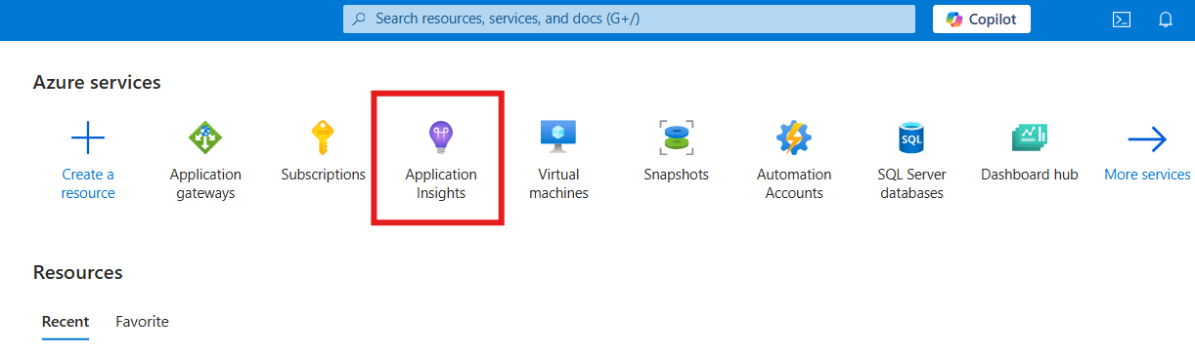

**Step 2:** Go to Smart Detection Settings

1. Navigate to Investigate → Smart Detection → Settings.
2. Click on the Smart Detection rule you want to configure.

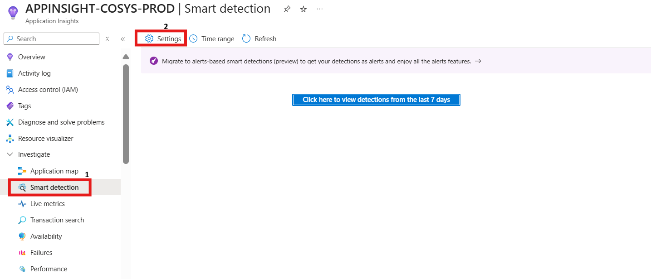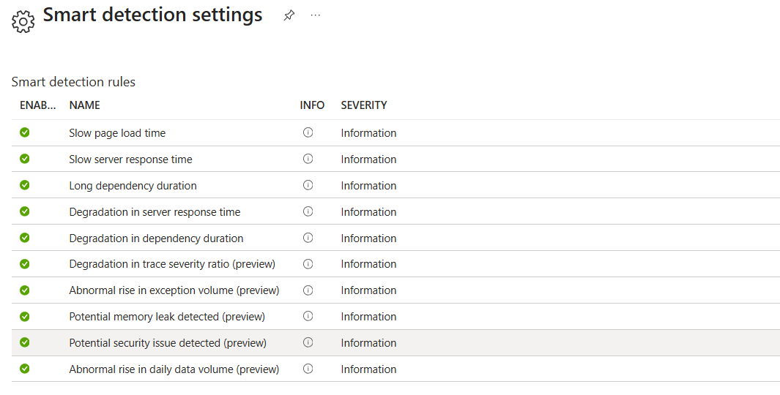

**Step 3:** Add Custom Email Recipients

1. Enable Email Notifications.

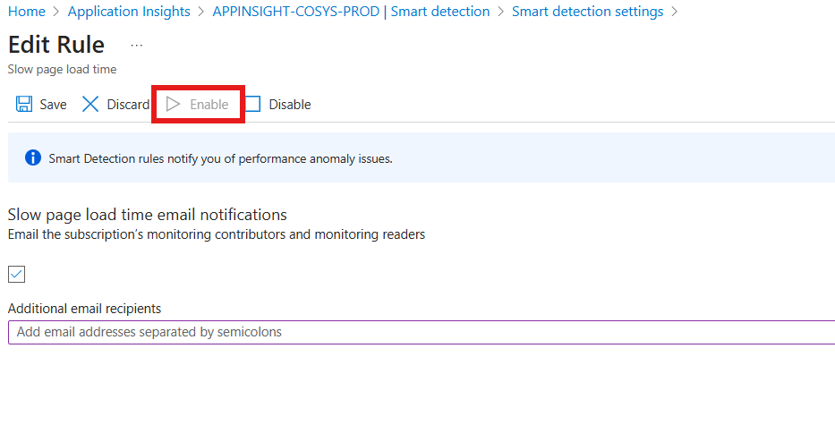

* Under Additional email recipients, add user or group email addresses.

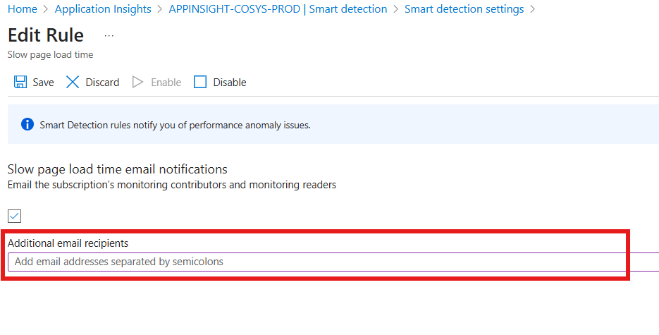

* Save the configuration.

